BLOCKMEDIARY | FINANCIAL REPORT
Financial Value and
Commercial Viability
Unit economics, five-year operating case, capital requirement and commercial validation

Investment view Each workflow tier produces positive transaction contribution before shared platform costs. Commercial viability still depends on distribution, regulatory execution and production controls.

£3.06m | Month 12 | £1.37m | Y4 M8
Initial operating funding | First paid pilot | Base Year-3 revenue | Monthly cash-flow break-even
Prepared by Team Transakt
Preliminary commercial planning report
Reference model: Blockmediary Financial Model, 13 August 2026
Status: preliminary planning report; not an audited forecast, valuation or investment recommendation

Executive conclusion
Blockmediary charges for prefunded, document-conditioned settlement. At the model's Year-1 deal sizes, the standard fee is £305 for a £35,000 Tier A eBL workflow, £540 for a £30,000 Tier B carrier/API workflow and £1,200 for a £30,000 Tier C paper workflow. Those fees equal 0.9%, 1.8% and 4.0% of deal value respectively, before any conditional dispute fee. Customers pay for payment assurance and document verification. Blockmediary does not lend, take FX risk or earn a spread on client money.
The base case reaches £76.0m of Year-3 gross merchandise value (GMV) across 2,000 deals. It converts that throughput into £1.371m of revenue, £1.057m of gross profit and a 77.1% gross margin, but still records negative EBITDA of £409k. Monthly cash-flow break-even occurs in Year 4, Month 8, after annual deal volume rises from 2,000 to 15,000 and active customers rise from 333 to 1,875. Transaction margins are positive before company profitability because payroll, fixed operating cost and regulatory overhead require much greater distribution scale.
Financial judgement Capital should be committed in stages. The initial operating requirement is £3,063,210; the low case needs £4,279,063 and remains below monthly break-even beyond Month 60.

Basis of analysis
Area | Model treatment | Boundary
Revenue model | Escrow, document, exception and partner/API fees | No lending margin, FX spread or client-fund yield
Planning horizon | 60 monthly periods with five annual summaries | Pre-tax and pre-financing operating case
Scenarios | Low, Base and High deal volumes and tier mix | Payroll, fixed opex and one-offs remain fixed
Capital treatment | Peak operating gap plus a liquidity reserve | VARA restricted capital is separate from runway
Current stage | Base Sepolia proof of concept using test USDC | No live revenue, customers or permission to handle real funds
Source: Blockmediary Financial Model, README, Assumptions, Launch Readiness, Scenario Engine and Client Funds Memo.

1. Commercial value by stakeholder
The buyer prefunds the agreed stablecoin amount, and the seller can verify that funds are locked before shipping. Release follows documented compliance and the objection process. Blockmediary charges for administering that workflow without advancing capital against the trade.
Stakeholder | Economic problem | Financial mechanism | Value interpretation
Buyer | Avoid paying the seller outright before shipment evidence exists | Funds remain locked pending document conditions | The service fee is small relative to the trade principal, but it is not an insurance guarantee
Seller | Avoid shipping with only an unsecured promise of later payment | Prefunding is visible before shipment; valid release does not depend on discretionary buyer approval | Economic value is faster, more certain access to agreed funds when documents comply
Blockmediary | Monetise trust without lending or balance-sheet credit exposure | Escrow, document, exception and partner/API fees | Base total revenue yield falls from 2.7% to 1.2% of GMV as scale and digital mix increase
Partner / regulator | Operate a controlled and auditable settlement perimeter | Client assets are gross memorandum balances with matching liabilities | 0% is available to operations and no client-fund yield is recognised
Sources: Financial Model, P&L 5yr!C7:G31 and Client Funds Memo!A5:H31; Trade Escrow Agreement, pp.2-4 and 18-19.

How much trade value is supported by each pound of revenue?
In the base case, the platform processes 55.4 pounds of Year-3 GMV for every pound of company revenue. The multiple expands to 80.6x by Year 5 because the digital tier gains share and the blended escrow take rate declines. GMV belongs to customers and is never company revenue or operating cash.
55.4x | 1.8% | 77.1% | £2.92m
Y3 GMV / revenue | Y3 total revenue yield | Y3 company gross margin | Y3 avg safeguarded assets
Boundary GMV, client escrow assets and future VARA restricted capital are not company cash. The model gives all three zero operating availability.

2. Economics of one transaction
Price formula Standard fee = max(deal value x tier take rate, minimum escrow fee) + document/review fee. Conditional dispute or amendment fees are excluded until the event occurs.

Tier | Workflow | Y1 deal | Take rate | Standard fee | Fee / deal | Conditional event fee
Tier A | eBL | £35,000 | 0.8% | £305 | 0.9% | £100
Tier B | carrier/API | £30,000 | 1.5% | £540 | 1.8% | £200
Tier C | paper | £30,000 | 3.0% | £1,200 | 4.0% | £500
Source: Financial Model, Assumptions!F63:F74 and F149:F154; Tier Economics!B3:U18. Standard fee excludes any dispute/amendment event.

Contribution economics before shared platform costs
Tier | Expected revenue / deal | Tier-specific variable cost | Contribution / deal | Margin before shared COGS
Tier A | £309 | £10.4 | £298.6 | 96.6%
Tier B | £560 | £48.0 | £512.0 | 91.4%
Tier C | £1,300 | £390.0 | £910.0 | 70.0%
Source: Financial Model, Tier Economics!B15:D26. Expected revenue includes probability-weighted dispute/amendment fees; costs exclude shared COGS, payroll and fixed overhead.
Tier A has the lowest cost to serve. At the Year-1 assumptions, a £305 standard customer fee supports a £35,000 trade. Expected revenue of £309 and tier-specific variable cost of £10.40 produce a 96.6% margin before shared platform cost. Year-1 company gross margin is lower at 71.1% after shared COGS, and EBITDA remains negative after payroll and fixed operating expenditure.
Tier B requires more document and human/API handling. It retains a 91.4% margin before shared COGS. Its £540 standard fee equals 1.8% of the modeled £30,000 deal value.
Tier C prices for manual paper processing. It has the highest fee, expected dispute rate and cost to serve. Its 70.0% margin before shared COGS remains positive but is materially below the digital tiers. The scale plan reduces the paper mix over time.
Validation requirement These prices are management hypotheses informed by the deal-value and competitor reports. They are not an observed tariff or proof of willingness to pay. The paid pilot must test conversion by tier, deal value and fee.

3. Digital mix creates operating leverage
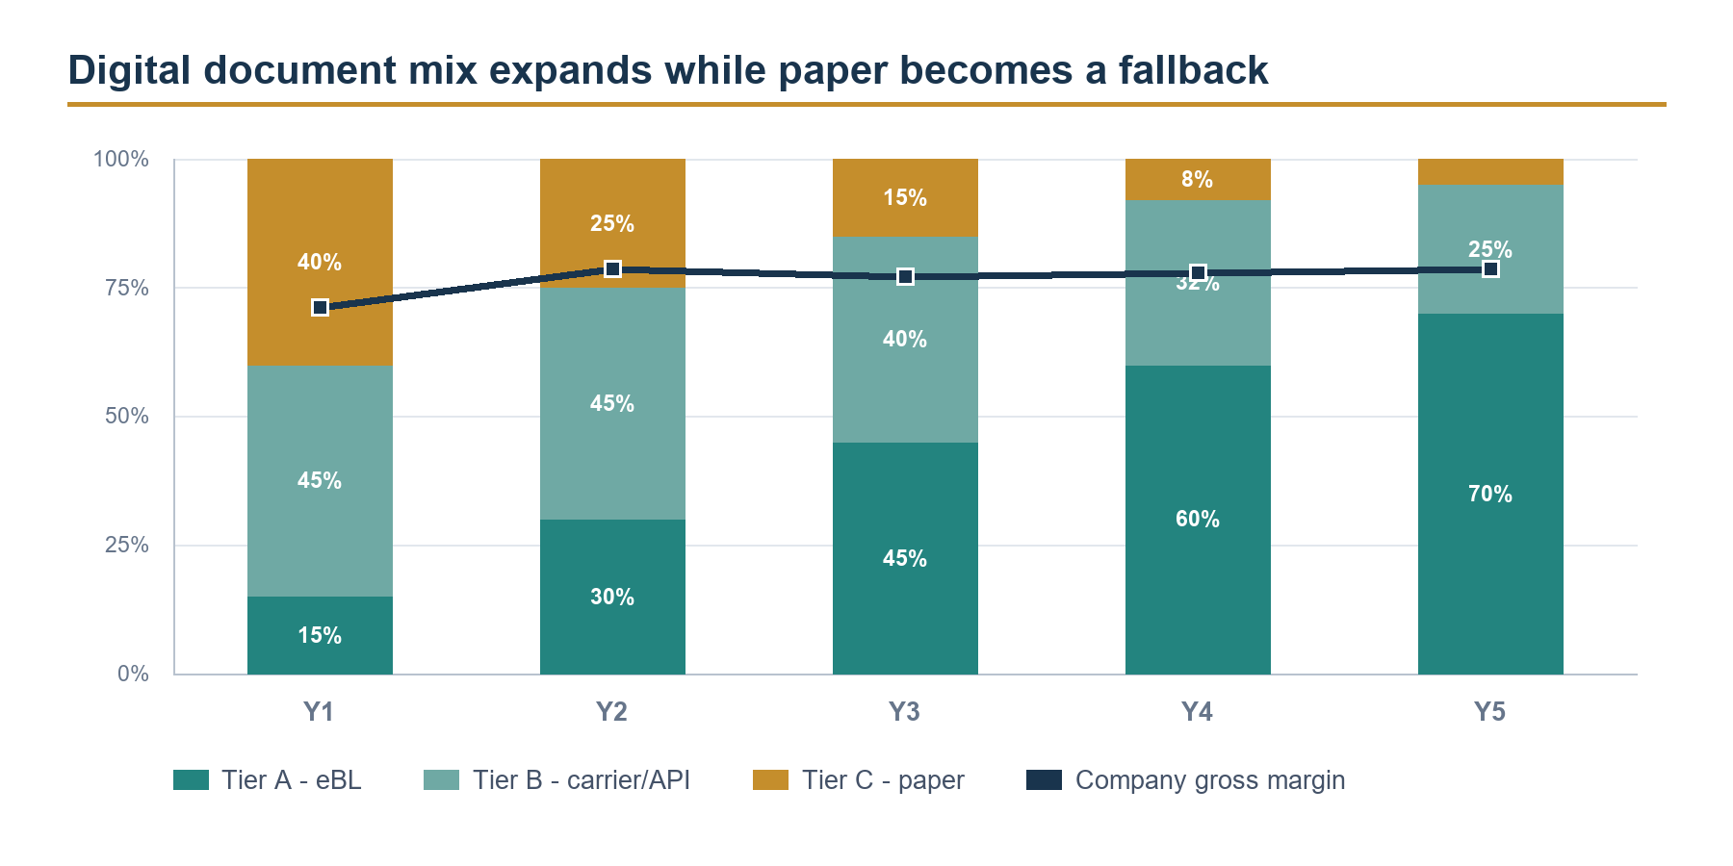
Figure 1. Base-case tier mix and company gross margin.
Source: Financial Model, Tier Economics!B3:U26 and P&L 5yr!C29:G31.
Metric | Year 1 | Year 3 | Year 5 | Commercial meaning
Tier A share | 15% | 45% | 70% | eBL becomes the dominant scale path
Tier C share | 40% | 15% | 5% | paper remains available but becomes exceptional
Blended escrow take rate | 2.0% | 1.3% | 1.0% | lower pricing accompanies digitisation
Documents per deal | 6.75 | 5.10 | 4.05 | weighted handling load declines
Margin before shared COGS | 78.1% | 86.9% | 93.1% | mix and automation improve contribution economics
Company gross margin | 71.1% | 77.1% | 78.6% | shared risk and operating costs keep the margin realistic
Source: Financial Model, Tier Economics!E4:U26 and P&L 5yr!C31:G31.
The digital document pathway costs less to operate than paper review. As digital tiers gain share, the blended escrow take rate falls from approximately 2.0% to 1.0% while whole-company gross margin stays within 71% to 79%. The forecast therefore depends on the modeled eBL/API adoption curve.

4. Five-year operating case
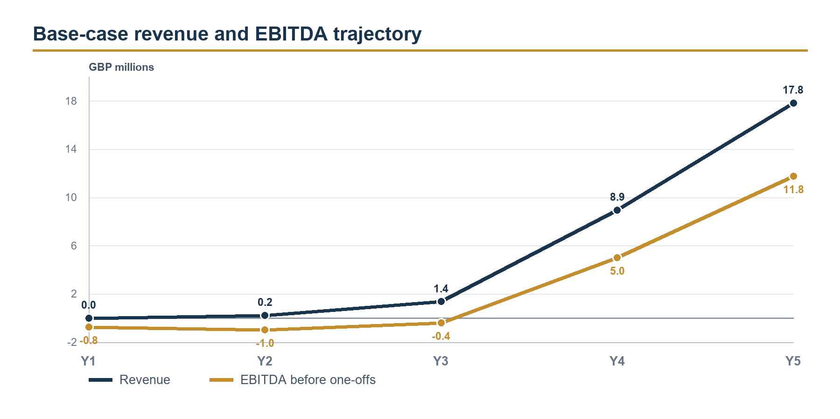
Figure 2. Base-case revenue and EBITDA trajectory.
Source: Financial Model, P&L 5yr!C18:G18 and C61:G61.
Year | Deals | Active customers | Avg deal | GMV | Revenue
Year 1 | 3 | 1 | £30,750 | £92.2k | £2.45k
Year 2 | 240 | 60 | £34,005 | £8.16m | £220k
Year 3 | 2,000 | 333 | £38,016 | £76m | £1.37m
Year 4 | 15,000 | 1,875 | £42,823 | £642m | £8.94m
Year 5 | 30,000 | 3,000 | £47,897 | £1.44bn | £17.8m
Source: Financial Model, P&L 5yr!C7:G18 and C69:G84. Active customers are model-implied targets, rounded for presentation.
Year | Gross profit | Gross margin | EBITDA before one-offs | Operating result | Cumulative result
Year 1 | £1.74k | 71.1% | (£764k) | (£1.11m) | (£1.11m)
Year 2 | £173k | 78.5% | (£990k) | (£990k) | (£2.1m)
Year 3 | £1.06m | 77.1% | (£409k) | (£409k) | (£2.51m)
Year 4 | £6.96m | 77.8% | £5m | £5m | £2.49m
Year 5 | £14m | 78.6% | £11.8m | £11.8m | £14.2m
Source: Financial Model, P&L 5yr!C29:G66. The model is pre-tax and pre-financing; corporation tax, interest and depreciation/amortisation are not modeled.

The Year-3 bridge: proof of monetisation, not yet profitability
Year-3 revenue stream | Amount | Share of total
Escrow transaction fees | £1,022,499 | 74.6%
Launch discounts and credits | (£69,871) | -5.1%
Document and exception-handling fees | £234,100 | 17.1%
Partner / API and ancillary services | £184,560 | 13.5%
Total revenue | £1,371,288 | 100.0%
Source: Financial Model, P&L 5yr!E14:E18.
Escrow fees provide 74.6% of Year-3 revenue. Document and exception fees provide 17.1%, and partner/API services provide 13.5%, partly offset by launch discounts and credits. Gross profit of £1.057m does not cover £1.015m of payroll and £451k of fixed operating expenditure. The business needs more deals, more revenue per active customer or slower fixed-cost growth before it becomes self-funding.

The Year-4 inflection is the largest assumption in the model
Scale test From Year 3 to Year 4, deals rise 7.5x, active customers rise 5.6x and revenue rises 6.5x. Gross new customers required per Sales/BD/CS FTE rise from 93 to 225, against a model warning threshold of 250.

The commercial capacity check remains within its modeled threshold, but it does not validate demand. The Year-4 and Year-5 outputs depend on partner distribution, self-serve onboarding, digital-document adoption and an AI-enabled operating model. They are conditional operating targets, not a straight-line forecast from the prototype.

5. Capital requirement and use of funds
The base case requires £3,063,210 of initial operating capital. This equals the modeled peak monthly operating deficit of approximately £2,871,700 plus a three-month operating reserve of £191,516. Future VARA restricted capital of £319,095 is separate and cannot be used as runway.
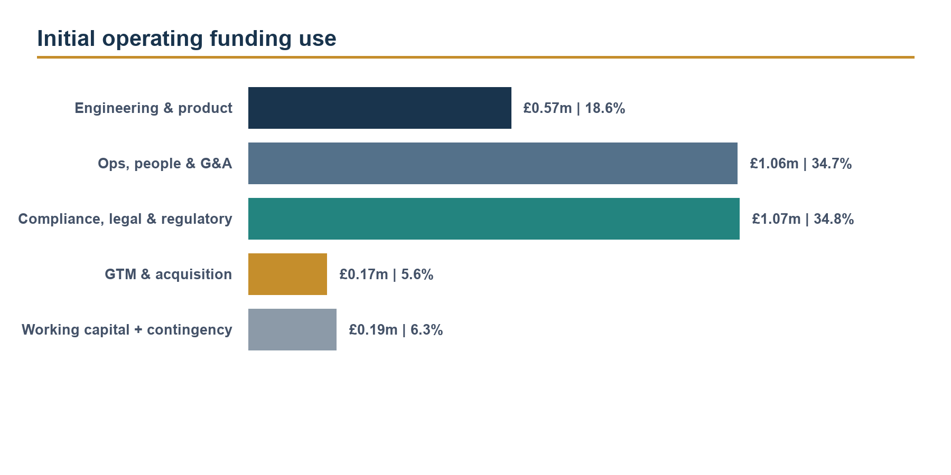
Figure 3. Initial operating funding allocation.
Source: Financial Model, Dashboard!J57:M62.
Capital item | Amount | Treatment
Peak operating cash gap | £2,871,700 | Maximum cumulative deficit before financing
Three-month operating reserve | £191,516 | Included in initial operating funding
Initial operating funding | £3,063,210 | Spendable operating runway
Future VARA restricted capital | £319,095 | Separate; not operating cash
Combined staged capital envelope | £3,382,305 | Derived total; not the initial ask
Source: Financial Model, Launch Readiness!E12:E17; P&L 5yr!F64:F66; Dashboard!J57:M62.

What the capital is buying
Operations, people and G&A account for 34.7% of the operating requirement. Compliance, legal and regulatory work account for a further 34.8%. Engineering and product are 18.6%, go-to-market is 5.6%, and reserve/contingency is 6.3%. The prototype reduces product-feasibility uncertainty, but production security, key management, partner integration and an independent audit remain outstanding.
Cost item | Model value | Financial treatment
First-six-month startup build | £243,412 | Includes 15% contingency
DIFC / regulated-partner pilot onboarding | £60,000 | Year-1 one-off
VARA application placeholder | £42,546 | Year-1 staged application cost
Total Year-1 startup and staged regulatory one-offs | £345,958 | Modeled operating expense
Partner-pilot oversight | £67,000 | Annual pilot-stage run-rate
VARA supervision placeholder | £102,110 | Annual cost after licensing
Sources: Financial Model, Startup 6mo!F40:F44 and Launch Readiness!A5:E17. VARA figures are planning placeholders pending counsel and regulator confirmation.

Reserve sensitivity
Reserve policy | Operating reserve | Funding need
3 months | £0.2m | £3.1m
6 months | £0.4m | £3.3m
9 months | £0.6m | £3.4m
Source: Financial Model, P&L 5yr!C89:E91. Rounded presentation values.

6. Downside, base and upside
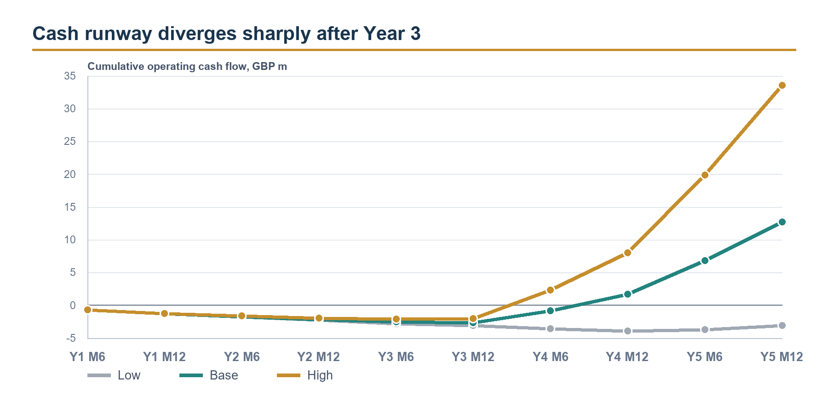
Figure 4. Six-month cumulative operating cash-flow checkpoints by scenario.
Source: Financial Model, Dashboard!B67:E77 and Cash Flow Statement!B45:F47.
Case | Y3 revenue | Y3 EBITDA | Y3 active customers | Monthly break-even
Low | £1.04m | (£748k) | 480 | Beyond Month 60
Base | £1.37m | (£409k) | 333 | Y4 M8
High | £1.91m | £100k | 320 | Y4 M4
Source: Financial Model, Scenario Engine!D30:P62 and Cash Flow Statement!B45:B47.
Case | Peak cash gap | Initial operating funding | Month-60 operating cash flow
Low | £4.088m | £4.279m | (£3.104m)
Base | £2.872m | £3.063m | £12.717m
High | £2.264m | £2.455m | £33.596m
Source: Financial Model, Cash Flow Statement!B45:F47 and Dashboard!J23:N28.
The low case remains cash negative through Month 60. It requires £4.279m of operating funding and ends the five-year period with cumulative operating cash flow of negative £3.104m. Payroll and fixed operating costs do not fall when commercial volume misses.
In the base case, monthly break-even occurs in Year 4, Month 8, and cumulative operating cash flow reaches positive £12.717m by Month 60 before financing. The result depends on the Year-4 volume step rather than a higher price assumption.
The high case reaches positive Year-3 EBITDA and monthly break-even in Year 4, Month 4, with a lower £2.455m initial operating requirement. It is an upside case rather than the fundraising base.

7. Current operating stage and dependencies
Blockmediary currently runs as a proof of concept on Base Sepolia testnet. It includes a non-custodial escrow contract, structured deal intake, deterministic document-rule grading, a release and refund path, an objection window, multi-deal dashboards and an audit trail. Mainnet deployment, independent security audit, hardware-secured release keys, live KYC/KYB/sanctions screening, AI/OCR extraction and regulatory permissions are not yet in place.
Dimension | Current position | Required before commercial scale
Settlement | Escrow create, fund, release and refund on Base Sepolia with test USDC | Mainnet/token approval, custody/control opinion, production key management
Document verification | Deterministic rules engine; structured bill-of-lading data | AI/OCR extraction, wider document set, human review console
Compliance | Requirements, risk register and legal template designed | Live KYB/KYC/sanctions controls, partner sign-off and licensing
Commercial | Pricing, deal values, tier economics and five-year model | Observed willingness to pay, paid pilot conversion, churn and deal frequency
Financial | 42 control checks pass and scenarios reconcile | Actual revenue, cost-to-serve, holding period and acquisition performance
Sources: repository README and Business Requirements Document; DIFC / VARA Readiness Report, pp.2-3 and 7-11; Legal and Compliance Risk Assessment, p.2.

Commercial and regulatory timeline
Timing | Milestone | Financial meaning
Now | Working testnet prototype | Technical feasibility and deterministic release workflow demonstrated
Month 1 | DIFC partner-pilot and VARA workstreams begin | Counsel, partner perimeter and application work start in parallel
Month 12 | First paying partner-led pilot | First external evidence for price, conversion and operating cost
Month 13 | First cash receipt | One-month collection lag modeled
Month 18 | Full VARA target - base timing | Wider Dubai scale route, subject to permission scope and approval
Y4 M8 | Monthly cash-flow break-even | Base case only; depends on the Year-4 distribution step
Sources: Financial Model, Launch Readiness!A19:J23 and Cash Flow Statement!B45:B47; DIFC / VARA Readiness Report, pp.1-3 and 11.
Current scope The testnet escrow and deterministic document-release workflow are operational. Blockmediary has no live revenue, customers or permission to transact with real funds.

8. What must be proven before scale capital
Before scale capital is committed, the paid pilot must measure each unobserved driver and replace the corresponding model assumption. The five-year outputs are operating scenarios, not a valuation.
Driver to validate | Minimum evidence | Model input to replace
Deal value distribution | 15-20 target SME interviews plus anonymised invoices; ideally at least 200 recent UAE forwarder jobs | Median, quartiles, right tail and share above £50k by tier
Willingness to pay | 20-30 target-user price tests and paid-pilot conversion | Conversion probability by tier, deal value and fee
Document operations | Time-and-motion study with documentary reviewers | Minutes per pack, rework, discrepancy, escalation and loaded cost
Commercial motion | Pilot cohort telemetry | Acquisition source, CAC, churn, deals per active customer and revenue per customer
Settlement operations | Pilot transaction telemetry | Funded-to-release days, failure rate, objection rate and support burden
Regulatory perimeter | Integrated DFSA / VARA / CBUAE memorandum plus partner responsibility matrix | Permission scope, entity design, capital, fees and launch legality
Sources: Deal Value Research Report, pp.24-25; DIFC / VARA Readiness Report, p.11; Financial Model, Assumptions, Tier Economics and Client Funds Memo.

Recommended financing discipline
Funding gate | Evidence required | Why it protects capital
Gate 1 - perimeter and production readiness | Integrated UAE perimeter advice, named regulated partner, responsibility matrix, production security and audit plan | Confirms that the proposed pilot can legally and safely generate evidence
Gate 2 - paid pilot | Signed pilot customer, measured price acceptance, document workload, funded-to-release time and exception rate | Replaces the highest-impact unobserved unit-economics assumptions
Gate 3 - repeatability | Repeat customers, partner channel evidence, stable gross margin and conversion by tier | Tests the Year-3 customer and deal-frequency bridge
Gate 4 - scale and licensing | Application progress, distribution capacity, product automation and control evidence | Supports the Year-4 volume step and wider licence investment
Interpretive recommendation based on the financial model and companion research; the workbook does not prescribe funding tranches.
Decision rule Do not release scale capital merely because technical milestones are complete. The paid pilot must replace price, workload, conversion and cycle-time assumptions with observed data.

9. Model integrity, definitions and limitations
Mechanical status PASS: 42 of 42 model checks pass, and the formula-error scan found 0 cached #REF!, #DIV/0!, #VALUE!, #NAME?, #N/A or #NUM! errors.

A PASS means the workbook reconciles mechanically: the scenario selector, P&L roll-ups, cash roll-forward, revenue and COGS ties, client-fund memorandum, use-of-funds bridge, launch timing and restricted-capital treatment all agree. It does not mean that customers will buy, regulators will approve the route on schedule or Year-4 distribution will occur.
Term | Meaning in this report
GMV | Customer transaction value processed. It is not revenue, profit or company cash.
Revenue | Escrow, document/exception and partner/API/ancillary fees after launch discounts.
Gross profit | Revenue less modeled variable and shared COGS.
EBITDA before one-offs | Gross profit less payroll and fixed opex; excludes startup/regulatory one-offs.
Operating result | Gross profit less payroll, fixed opex and modeled one-offs; pre-tax and pre-financing.
Peak cash gap | Largest cumulative monthly operating deficit before financing.
Operating reserve | Spendable liquidity cushion included in the initial ask.
Restricted capital | Regulatory capital held separately; not spendable runway.
Safeguarded client assets | Gross customer escrow balance with an equal liability; 0% available to operations.
Source: Financial Model README, P&L 5yr, Launch Readiness, Cash Flow Statement and Client Funds Memo.

Material limitations
1. No operating history. Deal volume, conversion, churn, CAC, review workload and holding period are assumptions or planning outputs, not observed performance.
2. No investment-grade valuation. The model is a five-year pre-tax, pre-financing operating plan. It does not model corporation tax, interest, depreciation/amortisation, working-capital accounting beyond the cash plan, or an enterprise valuation.
3. Year-4 and Year-5 are ambitious. The base case depends on partner distribution, self-serve onboarding, digital documents and an AI-enabled staffing model.
4. Regulatory figures are placeholders. The VARA application, supervision and restricted-capital assumptions require confirmation from counsel, the partner and regulators.
5. Client-fund timing is provisional. Average safeguarded balances use a 14-day funded-to-release period. A 30-, 60- or 90-day cycle materially increases safeguarding scale but still creates no operating cash.
6. Pricing is not willingness-to-pay evidence. The price book is informed by deal-value and competitor research; only a paid pilot can validate conversion and retention.

Financial conclusion
Prefunding avoids balance-sheet credit exposure. Tiered pricing covers the higher cost of manual workflows, while digital adoption allows the take rate to decline without removing transaction contribution. Client funds remain segregated from company cash.
The base case requires £3.063m, records first revenue after Month 12 and depends on a large Year-4 increase in distribution. Capital should first fund the regulated pilot and production controls. Further funding should follow observed price acceptance, workload, cycle time, repeat use and partner-led distribution.
Financing recommendation Commit capital to the regulated pilot and production controls first. Release scale capital only after paid transactions validate the main commercial assumptions.

References and model source map
Ref. | Source
[1] | Team Transakt, Blockmediary Financial Model, 13 August 2026.
[2] | Blockmediary, Defensible Average Deal Values for Documentary Escrow, 11 August 2026, especially pp.2-6 and 24-25.
[3] | Blockmediary, DIFC Partner-Led Pilot and VARA Scale Readiness Report, 12 August 2026, especially pp.1-3 and 11.
[4] | Blockmediary, Competitor Analysis, August 2026, especially pp.2-3 and 12-13.
[5] | Blockmediary, Legal and Compliance Risk Assessment, August 2026, especially pp.2-4 and 22-24.
[6] | Blockmediary, Trade Escrow Agreement, August 2026, especially pp.2-4 and 18-19.
[7] | Blockmediary repository README and Business Requirements Document, baselined 9 August 2026.

Primary workbook locations
Topic | Workbook location
Executive headlines and use of funds | Dashboard
Launch timing, regulatory costs and initial funding | Launch Readiness!A5:J23
Tier price book, revenue, cost and contribution | Tier Economics!B3:U35
Five-year operating case and customer bridge | P&L 5yr!C7:G91
Monthly cash flow and break-even | Cash Flow Statement!B9:BI58
Low / Base / High cases | Scenario Engine!A1:R64
Safeguarded client assets | Client Funds Memo!A5:H31
Mechanical validation | Model Checks!A1:G48
Model inputs and source notes | Assumptions; Driver Tables; Risk Register
Financial figures are drawn from the Blockmediary Financial Model dated 13 August 2026 and rounded for presentation. The workbook remains the numerical source of truth.

